|  |
| --- |
| **Midterm-EXAM** |
| CS551 Advanced Software Engineering |
|  |
|  |
| **PREETHI REDDY PESARU ID: 16159068** |
| **4/6/2014** |
|  |

1. Design
2. Architecture Diagram

clclc

Browser

Client

Web server

Invalid JSON primitive: No.

Security

Communication

UI components

UI process components

Components

Business

Workflows

Entities

Components

Data

Utilities

Agents

Services

Database Server

1. Class Diagram

Home Page

Address

Search Text

Contact

Email ID

About

Get Address button

maps

Search Button

maps

1. Features Implemented
2. Web Services

Existing Services API:

I have used the following API’s in order to run my web application

* Google Maps API
* Foursquare

1. Mobile User Interface

Features:

* Address text field,
* Search text field box,
* Search button,
* Get Address button, and
* A toolbar which includes Home page, Contact page and About page.

Styles:

Cascading Style Sheet

Technologies:

We are using

* XML
* CSS
* CS
* ASP.NET

I have implemented the web application using the **Microsoft Visual Studio 2013**

Existing Design:

Adopted some of the features of Foursquare web site

1. Screen shots

This is the home screen of my web application (Trip Router). It has certain features like Address box, Search Text box and two buttons one is the Search button and other is the Get Address button.

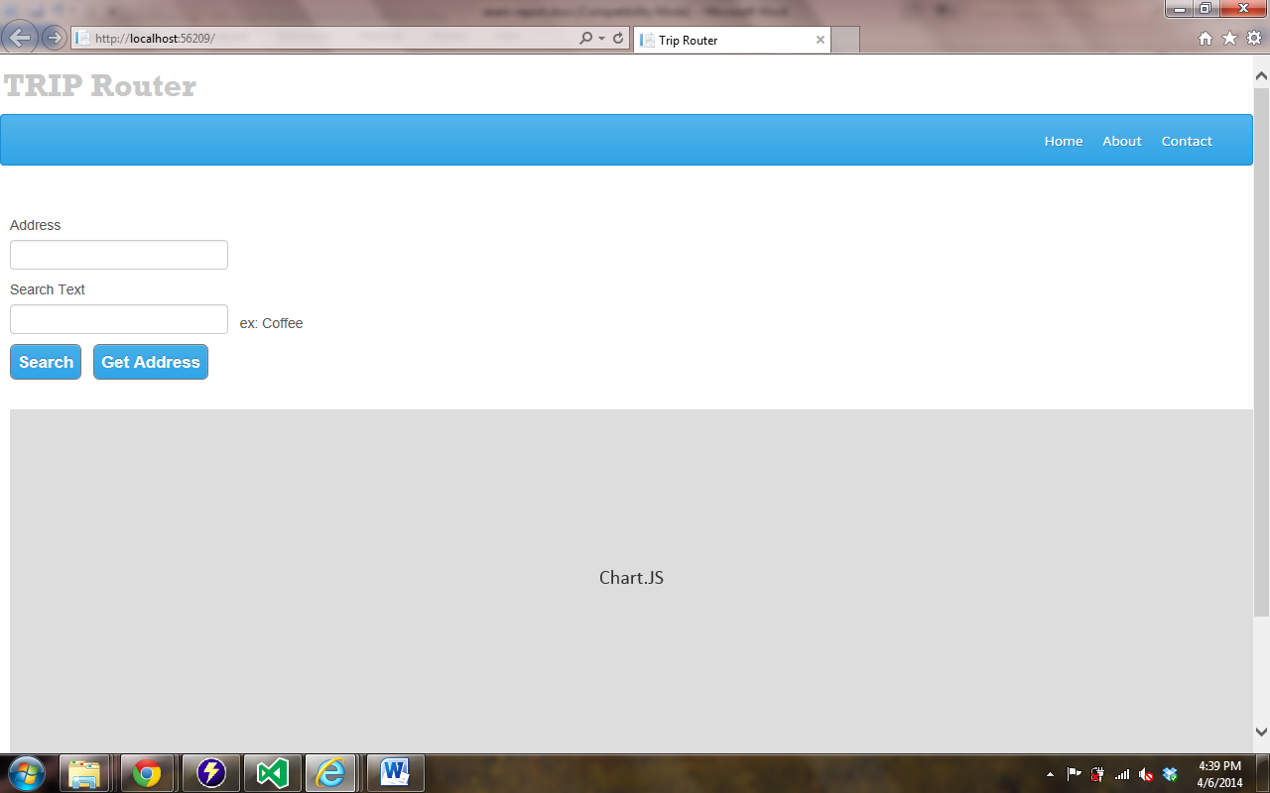

Here when we click on the Get Address button without typing any address and search text in the text field boxes, the asks for the permission whether to track our physical location or not. Below is the screen shot for this

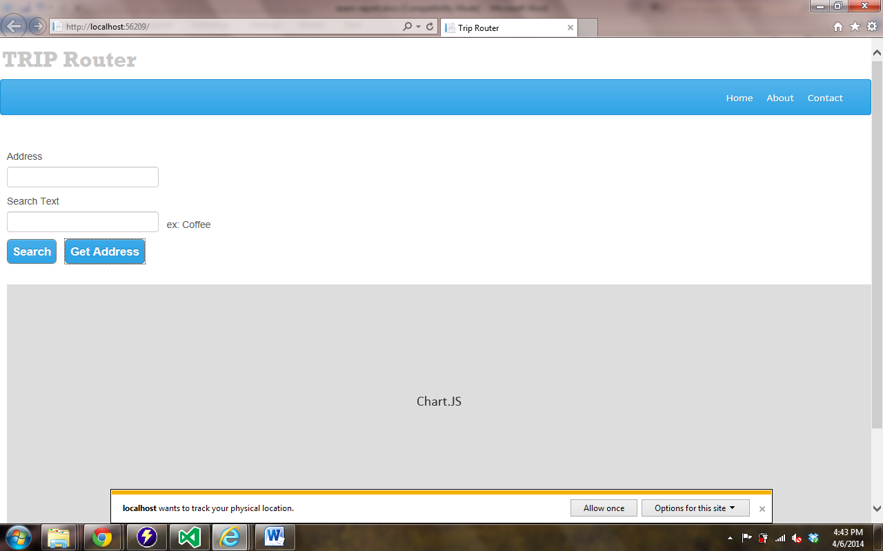

After clicking on allow once button we get our current address of where we are in the address text box.

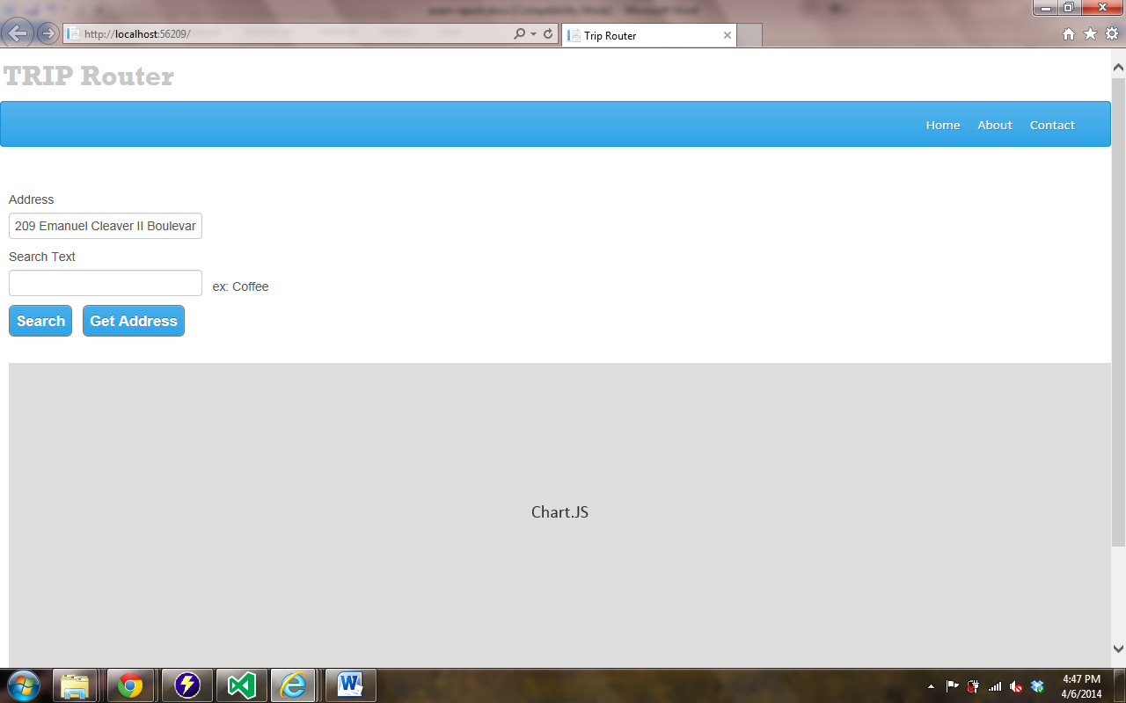

Now in the search text box enter a valid place to find the address so that the address is found at google maps so that the user can know the information.

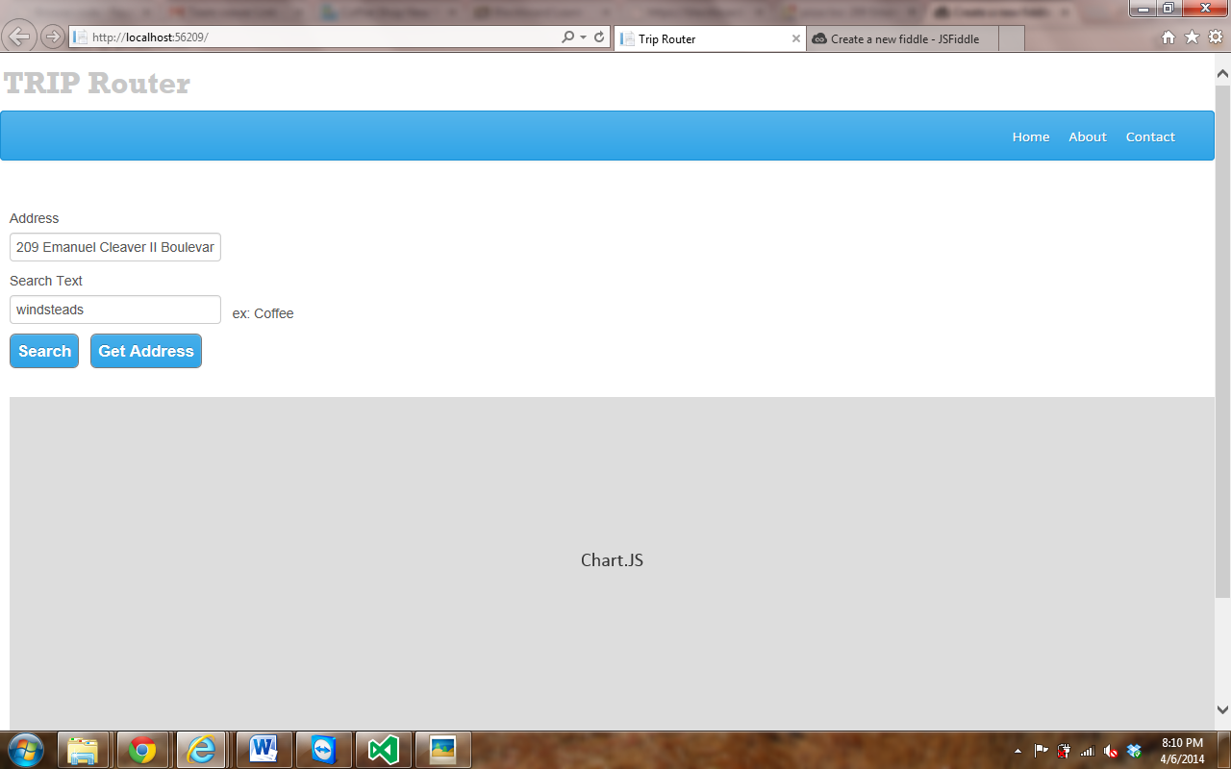

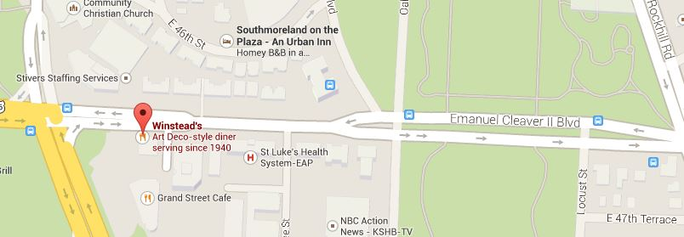

Here are some of the examples of the screen shots for finding places arround the world by tracking a address througn trip router 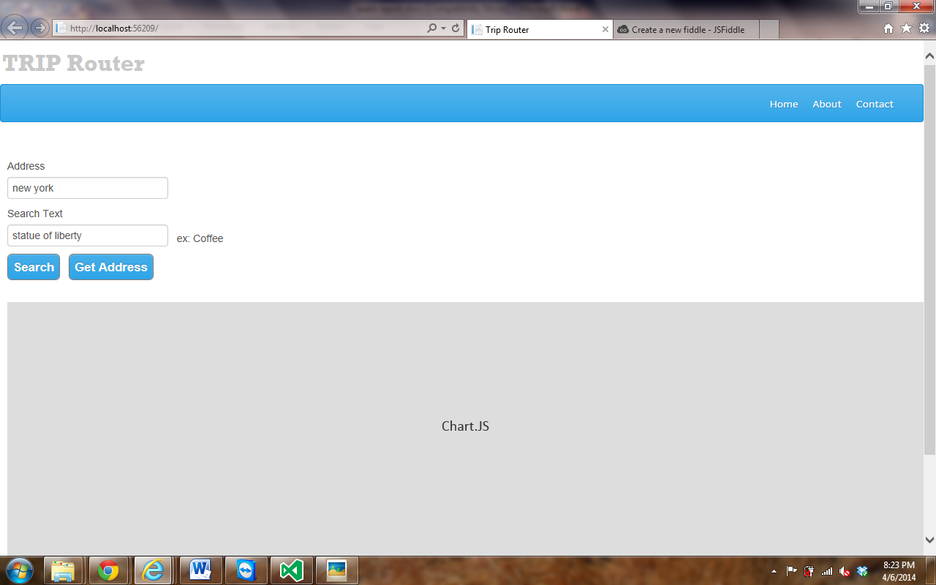



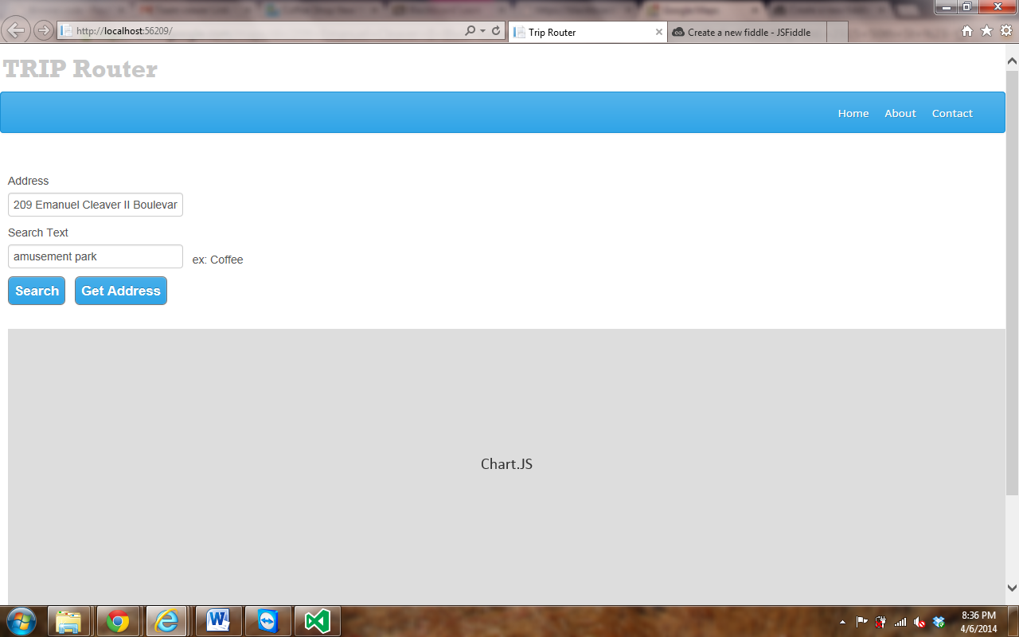

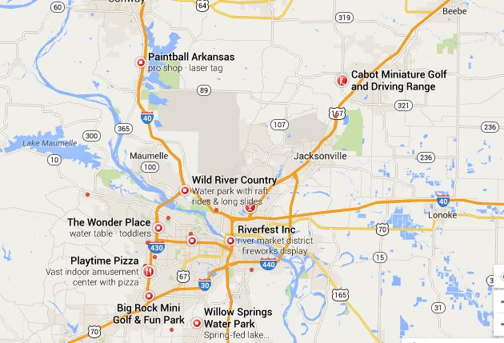

1. Web services and web site URL’s

Web services:

JSON

XML

WEB TEMPLATES

.NET FRAMEWORK

Web site URL’s:

[www.googlemaps.com](http://www.googlemaps.com)

[www.youtube.com](http://www.youtube.com)

<https://foursquare.com/>

<https://developer.foursquare.com/star>

[www.codeflex.com](http://www.codeflex.com)

1. Github URL link:
2. Limitations:

* In this application we can track the address of our current location by clicking the Get address button.
* In this way we can only track our current location but not the places around us.
* There is no login information required it is open to everyone so it might harm the application.
* Security problems.

1. References:

https://foursquare.com/

https://developer.foursquare.com/start

https://developers.google.com/

[www.wikipedia.com](http://www.wikipedia.com)

[www.youtube.com](http://www.youtube.com)

<http://code.msdn.microsoft.com/FourSquare-Analytics-0bb1c853>

msdn.microsoft.com